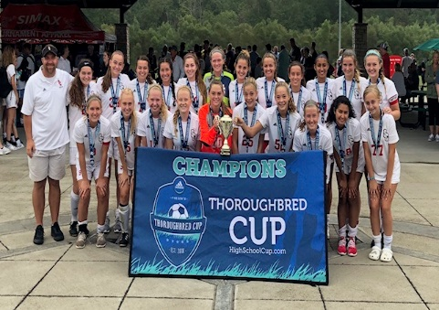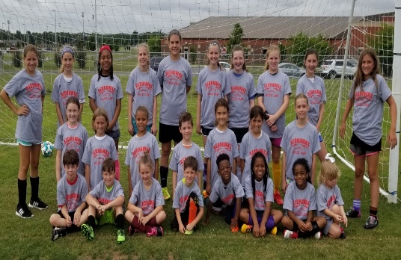2019

Lady Red Hawks

Soccer Camp

Camp Features:

* Footskills and Dribbling
* Passing and Receiving
* Speed and Agility
* Positioning
* 1v1 and Team Games



@ Stewarts Creek High School

June 11th, 12th, and 13th

8:00 am – 10:30 am

For girls and boys currently in

PreK – 8th grades

Campers should bring water bottle, shin guards, cleats, sunscreen, and a ball

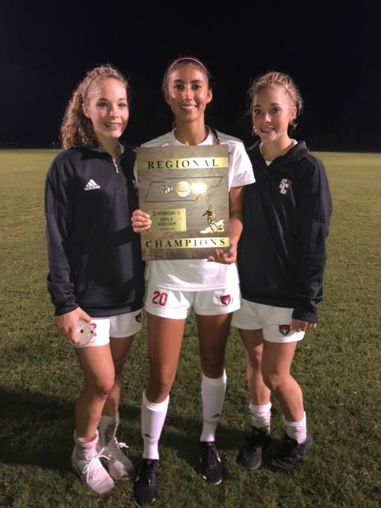

Every camper receives a t-shirt with early registration!

Pre-pay by cash or money order (payable to SCHS Girls Soccer) before May 25th.

**COST $60**

*Registration at door   
COST $75 (cash only)*

**Camp Directors**

**Coach Jeff Marlow**  
*Head Coach, SCHS Girls Soccer*Contact for more information:  
marlowj@rcschools.net

**Assistant Coaching Staff & Current Players***SCHS Girls Soccer*

Please mail completed registration form and full payment to:

Lady Red Hawks Soccer Camp

ATTN: Girls Soccer – Coach Jeff Marlow

301 Red Hawk Parkway, Smyrna, TN 37167

Camper Name: ____________________________________

Parent/Guardian Name:_____________________________  
  
Parent/Guardian Email:_____________________________

Phone # : _______________________________  
**\*Number at which you can be reached at all times**

Address: ____________________________________

City:_________________ State: _______ Zip: ________

Grade in school (2019—2020): _________

Shirt Size: Youth S M L XL

Adult S M L XL

**Release of Liability & Authorization for Medical Treatment**

*No one will be allowed to participate before this portion is complete!*

I/We further release Stewarts High School, Jeff Marlow, and all other employees of the camp from any liability for damage and injury to the above individual and hereby accept the full responsibility for any and all damages or injuries sustained as a result of participation of the Stewarts Creek High Lady Red Hawks Soccer Camp. I also grant permission for my child to be treated by a member of staff, licensed physician, or athletic trainer in the event of injury, illness, or mishap.

Parent/Guardian Signature:___________________________________

Date: _________________